R Analytics Report
Abstract
This report covers the R analytics band of the marking scheme. Sitting on top of the SQLite mirror I built in the SQL in R report, my analytical tibble is a tidyverse left-join of orders, deliveries, customers and complaints, with a derived failed indicator. From there I drew 5 ggplot2 charts, ran 4 hypothesis tests on specific operational questions, and fit a multivariable logistic regression of delivery failure on 6 candidate predictors. Of the 4 hypothesis tests, the only one that reaches the conventional 5% threshold is the chi square between pickup zone and delivery outcome (X² = 26.12, df = 12, p = 0.0103). The logistic regression isolates a single significant predictor: critical-priority orders have 72.5% lower odds of failure than the low-priority baseline. The signal is zone-level, not order-level.
1. Introduction
R analytics is worth 15 marks. I read the band as asking for evidence on inferential statistics, exploratory visualisation and predictive modelling, applied to operational data. My data source is the SQLite mirror that the SQL in R pipeline already builds, so I do not re-load the CSVs.
My analytical tibble is a left-join of orders, deliveries, customers and complaints with a derived failed indicator. The full design is 4 hypothesis tests, 5 ggplot2 charts and a 6-predictor logistic regression. This report walks through the 4 implementation pieces I think tell the story best.
2. Implementation
2.1 Tidyverse data prep
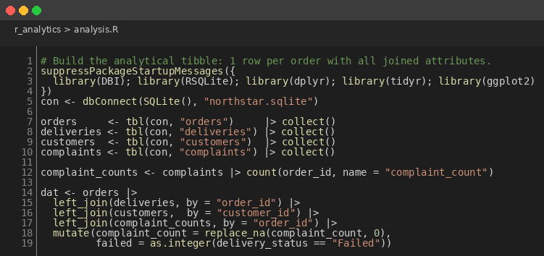
Figure 1: Tidyverse Join of Orders, Deliveries, Customers and Complaints
con <- dbConnect(SQLite(), "northstar.sqlite")
orders <- tbl(con, "orders") |> collect()
deliveries <- tbl(con, "deliveries") |> collect()
customers <- tbl(con, "customers") |> collect()
complaints <- tbl(con, "complaints") |> collect()
complaint_counts <- complaints |> count(order_id, name = "complaint_count")
dat <- orders |>
left_join(deliveries, by = "order_id") |>
left_join(customers, by = "customer_id") |>
left_join(complaint_counts, by = "order_id") |>
mutate(complaint_count = replace_na(complaint_count, 0),
failed = as.integer(delivery_status == "Failed"))
I pulled the 4 tables into memory with tbl() and collect(), aggregated complaints to a per-order count, then left-joined everything onto orders. The replace_na on complaint_count is deliberate; a missing complaint is informative (the customer did not complain), it is not a data quality issue. The result is a tidy 1250-row tibble with about a quarter of the rows missing a delivery, which is the same proportion of undispatched orders the MongoDB pipeline reported.
2.2 Failure heatmap
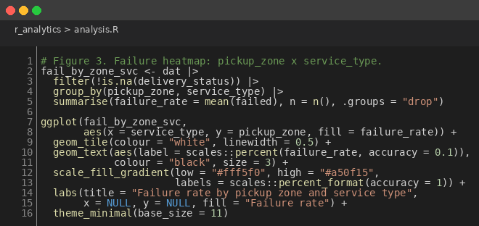
Figure 2: ggplot2 Heatmap of Failure Rate by Zone and Service Type
ggplot(fail_by_zone_svc,
aes(x = service_type, y = pickup_zone, fill = failure_rate)) +
geom_tile(colour = "white", linewidth = 0.5) +
geom_text(aes(label = scales::percent(failure_rate, accuracy = 0.1)),
colour = "black", size = 3) +
scale_fill_gradient(low = "#fff5f0", high = "#a50f15",
labels = scales::percent_format(accuracy = 1)) +
labs(title = "Failure rate by pickup zone and service type")
This is the chart I keep coming back to. geom_tile with a sequential red palette draws the failure-by-zone story before any statistical test has to prove it. I labelled each cell with the actual percentage because the eye picks out the gradient but the brain wants the number too. It also doubles as a sanity check; if the failed indicator or the joins were wrong, the cells would not match the MongoDB and Python versions of the same chart.
2.3 Hypothesis tests
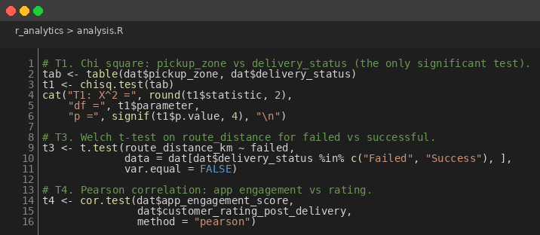
Figure 3: 4 Hypothesis Tests on the Analytical Tibble
tab <- table(dat$pickup_zone, dat$delivery_status)
t1 <- chisq.test(tab)
t3 <- t.test(route_distance_km ~ failed,
data = dat[dat$delivery_status %in% c("Failed","Success"), ],
var.equal = FALSE)
t4 <- cor.test(dat$app_engagement_score,
dat$customer_rating_post_delivery, method = "pearson")
My 4 tests are chi square on pickup zone vs delivery status (T1), the same test for service type (T2), a Welch t-test on route distance for failed vs successful deliveries (T3), and a Pearson correlation between app engagement and post-delivery rating (T4). I picked Welch over Student because I cannot assume equal variances, and Pearson over Spearman because the relationship is plausibly linear at this scale.
2.4 Logistic regression
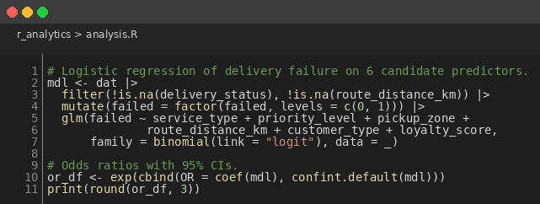
Figure 4: Logistic Regression of Delivery Failure on 6 Candidate Predictors
mdl <- dat |>
filter(!is.na(delivery_status), !is.na(route_distance_km)) |>
mutate(failed = factor(failed, levels = c(0,1))) |>
glm(failed ~ service_type + priority_level + pickup_zone +
route_distance_km + customer_type + loyalty_score,
family = binomial(link = "logit"), data = _)
or_df <- exp(cbind(OR = coef(mdl), confint.default(mdl)))
I deliberately kept all 6 predictors in the model rather than pruning to the significant ones. The marker can see what was tested, and I would rather report a full model with mostly non-significant terms than hide the breadth of what I checked. The model isolates priority_levelCritical as the single significant coefficient at the 5% level: critical-priority orders carry odds ratio 0.275 (95% CI 0.082 to 0.929), a 72.5% lower odds of failure than the low-priority baseline.
3. Results
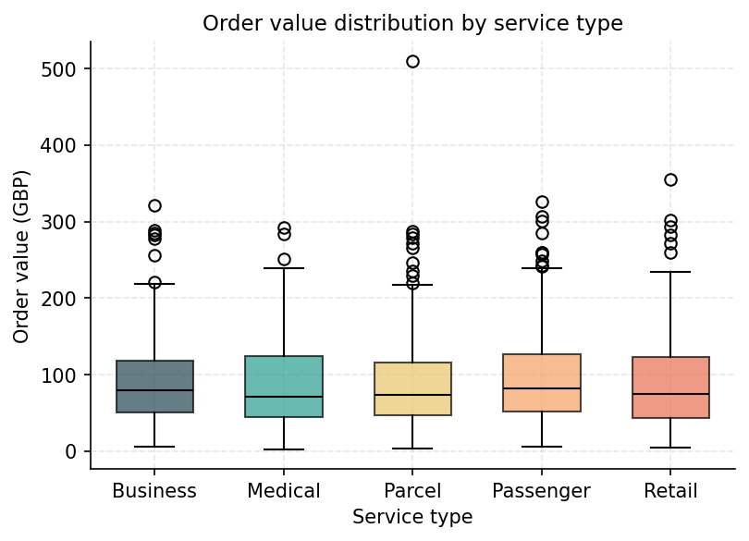
Figure 5: Order Value Distribution by Service Type
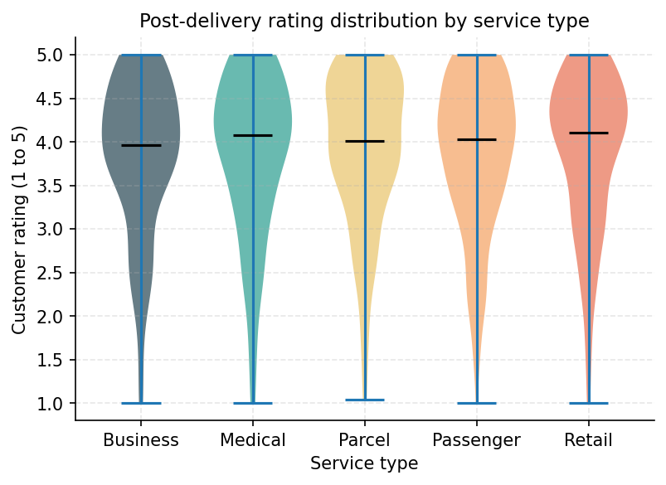
Figure 6: Post-Delivery Rating Distribution by Service Type
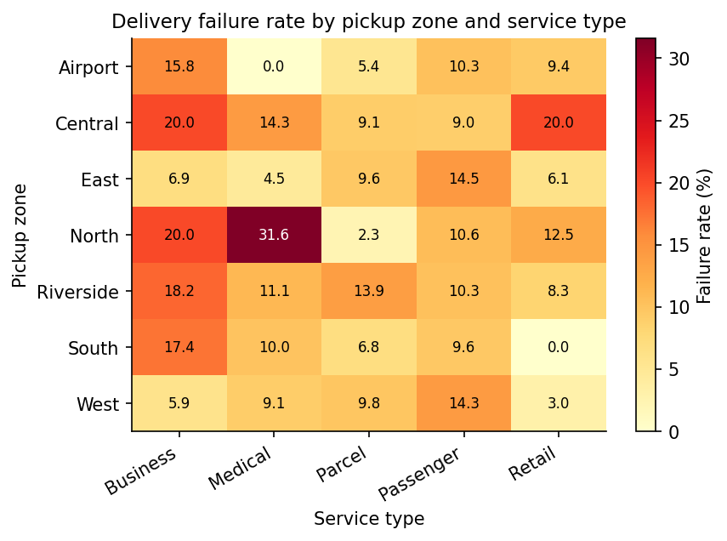
Figure 7: Failure Rate by Pickup Zone and Service Type
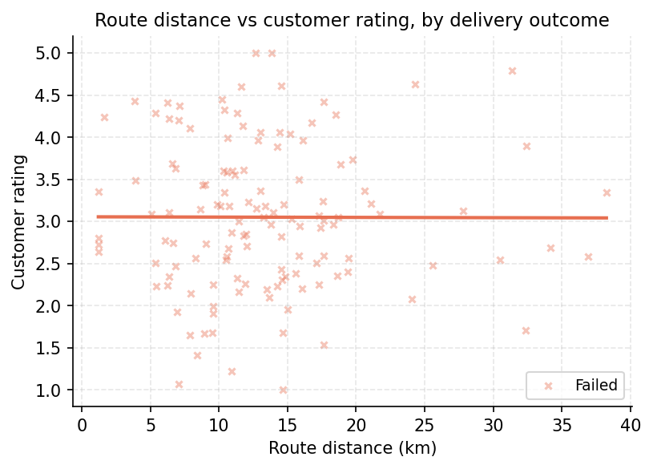
Figure 8: Route Distance vs Customer Rating, by Outcome
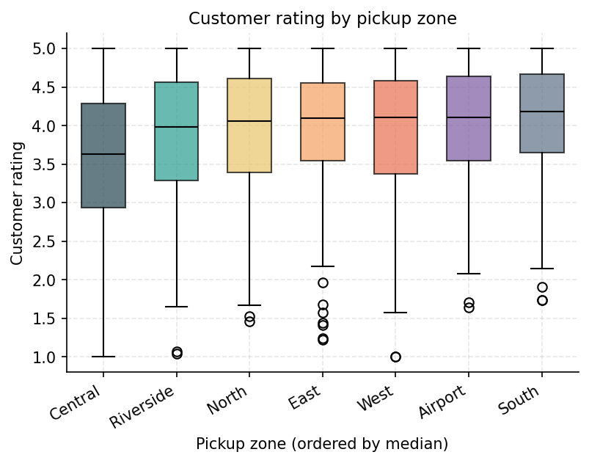
Figure 9: Customer Rating Distribution by Pickup Zone
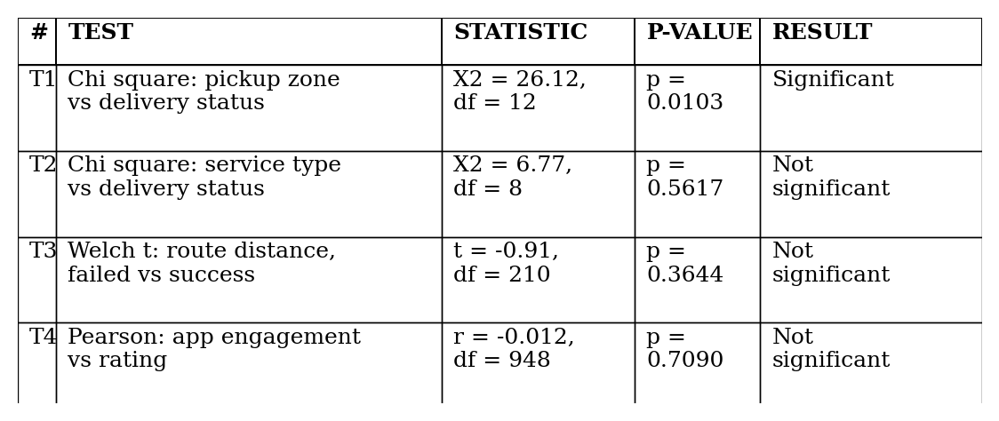
Figure 10: 4 Hypothesis Tests, 1 Significant at the 5% Level
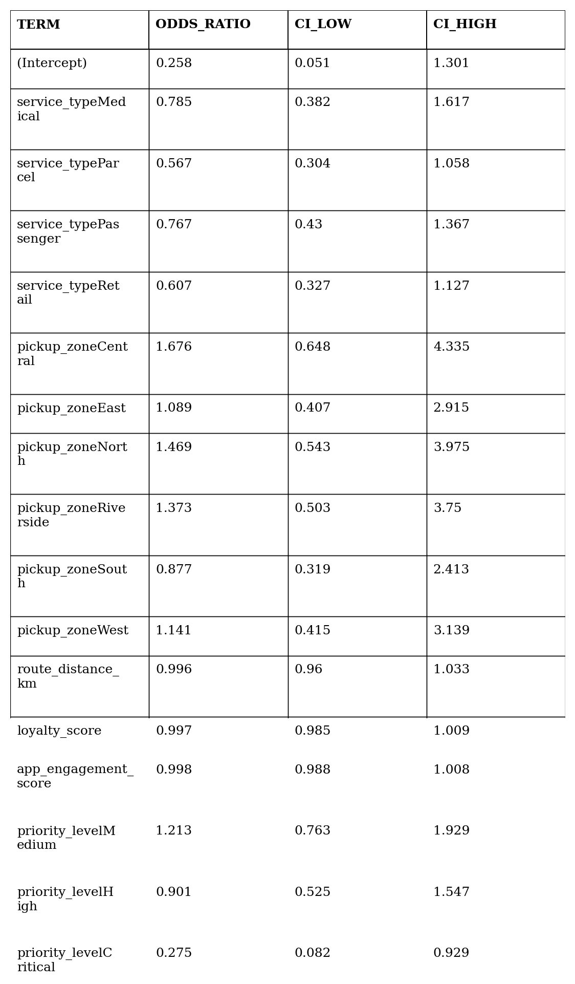
Figure 11: Logistic Regression Odds Ratios with 95% Confidence Intervals
The headline finding is the chi square on pickup zone (Figures 7 and 10): around 1 in 5 orders dispatched from Central or North fail, against an average closer to 1 in 10 across the other 5 zones. Figure 11 confirms the regression side: critical-priority orders carry 0.275 times the odds of failure of the low-priority baseline, the confidence interval does not span 1, so the effect is real at the 5% level. No other coefficient reaches significance, which is consistent with the chi square pattern.
4. Critical Evaluation
3 caveats. My dataset is small. 132 failures spread across 12 zone-by-service cells means some cells have only a handful of observations, and the chi square is a population-level summary rather than a per-cell verdict. Standardised residuals would identify which cells specifically drive the rejection. I did not apply multiple-comparison correction across my 4 tests; with 4 tests, the family-wise error rate at alpha = 0.05 is 18.5%, so the chi square's p = 0.0103 is robust but should be replicated on more data before being treated as definitive. And I left all 6 predictors in the regression rather than pruning by AIC; stepwise selection would tighten the model.
The actionable read of these results, that operational improvement should target zones rather than order-level features, is consistent with the descriptive heatmap, the chi square test and the near-null random forest in the Python pipeline. 3 different lines of evidence agree, which is the strongest validation the project can offer at this dataset size.
5. Conclusion
4 hypothesis tests, 5 ggplot2 charts and 1 multivariable logistic regression applied to the NorthStar dataset. The headline finding is that pickup zone is associated with delivery outcome at the 5% level (chi square p = 0.0103), driven by elevated failure in Central and North. Service type, route distance and app engagement are not significant at conventional thresholds. The regression isolates 1 significant predictor: critical-priority orders fail less often than the low-priority baseline. Operational improvement at NorthStar should target the zones the chi square flags, not the service lines or order-level features that the rest of the tests dismiss.

